 | 2022 Registration  ADS Convention  Friday, April 29 through  Sunday Evening, May 1, 2022  Gettysburg, Pennsylvania | 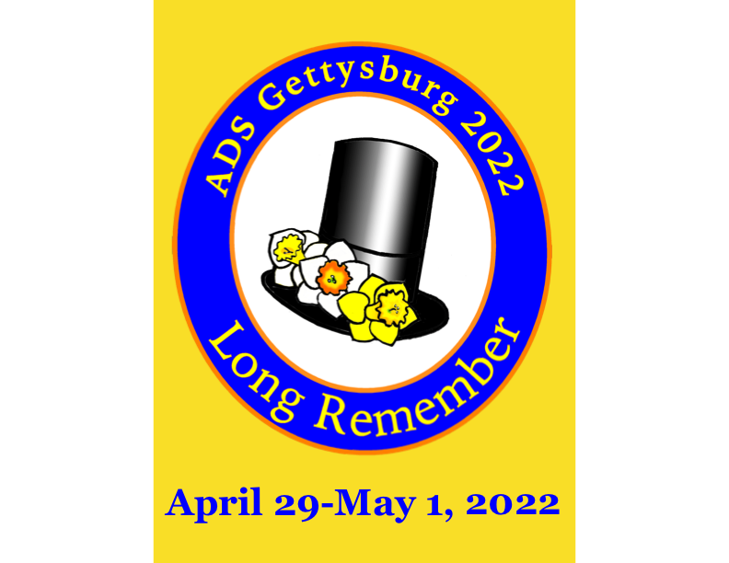
Wyndham Gettysburg, 95 Presidential Circle, Gettysburg, PA 17325  Phone: 717-339-0020 or 866-845-8885 If using Wyndham Rewards, call hotel directly or click this hotel reservation link: Hotel Reservation Link  Rates guaranteed until March 28th or until block is sold out. BOOK EARLY |  | Room Rate is $136.00 for 2 Queens or  1 King, Suites $174.00  from Wed April 27th through Tues May 3rd.
EARLY DEADLINE: March 24, 2022 FINAL DEADLINE: April 15, 2022
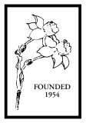
(Please complete a separate form for each attendee)
Name ___________________________________________________ Nickname for name tag _______________________________

Street Address _______________________________________________________________________________________________

City ________________________________________State ______________Zip ___________Country________________________

Telephone ______________________________E-mail (for confirmation) ________________________________________________
Special dietary needs: __________________________________________________________________________

The 2022 ADS Convention Registration Fee for the three-plus days includes:
- Friday evening dinner, Annual Membership Meeting, and Show Awards presentation
- Saturday and Sunday entry to convention program sessions
- Saturday Gettysburg Visitor Center and Bus Tour of Battlefield
- Judges Refresher
- Saturday box lunch and evening dinner with speaker
- Sunday Bus Trip through apple orchards, visits to a private garden and a daffodil garden party with entertainment and garden hat contest.
- Sunday brunch at the hotel and evening dinner at hotel with speaker.
Registration Fee:
Paid and Postmarked on or before March 24th …………………………….................................$ 375___________
Paid and Postmarked after March 24th ...………………………………………………………..$ 425___________
*Note: April 15th is the cut-off date for all registrations. Attendees are encouraged to pay on the ADS Webstore and mail or email the registration form per below. There will be no on-site registrations.
Optional Costs:
Optional Friday bus tour to Shriver House, lunch at historic Farnsworth House. $ 45__________
Minimum 25, maximum 40.
Hybridizers Breakfast. $ 25__________
To receive ADS credit for Judges Refresher………………………………………….…… $ 5__________
Optional Horse Back battlefield tour to be arranged on your own through hotel concierge
Optional Ghost Tour to be arranged through hotel concierge
Optional additional donation to the 2022 Daffodil Convention…………………………………… $ __________
TOTAL $ __________
____________
- I sent registration form and check(s) payable to “ADS” to: Alison Ezell
300 East Evans St. C306, West Chester, PA 19380
- I paid through the ADS Webstore *
https://stores.daffodilusastore.org/
*Send completed registration via US mail or email to ADSGettysburg2022@gmail.com

Check all that apply:
- This is my first ADS convention
- I plan to bring cut flowers for the show
- I plan to bring potted daffodils for the show
- I plan to bring photos to enter in photo show

