 | 2019 Registration  ADS Convention  Thursday, May 2 through  Sunday Evening, May 5  Bloomington, Minnesota |  | 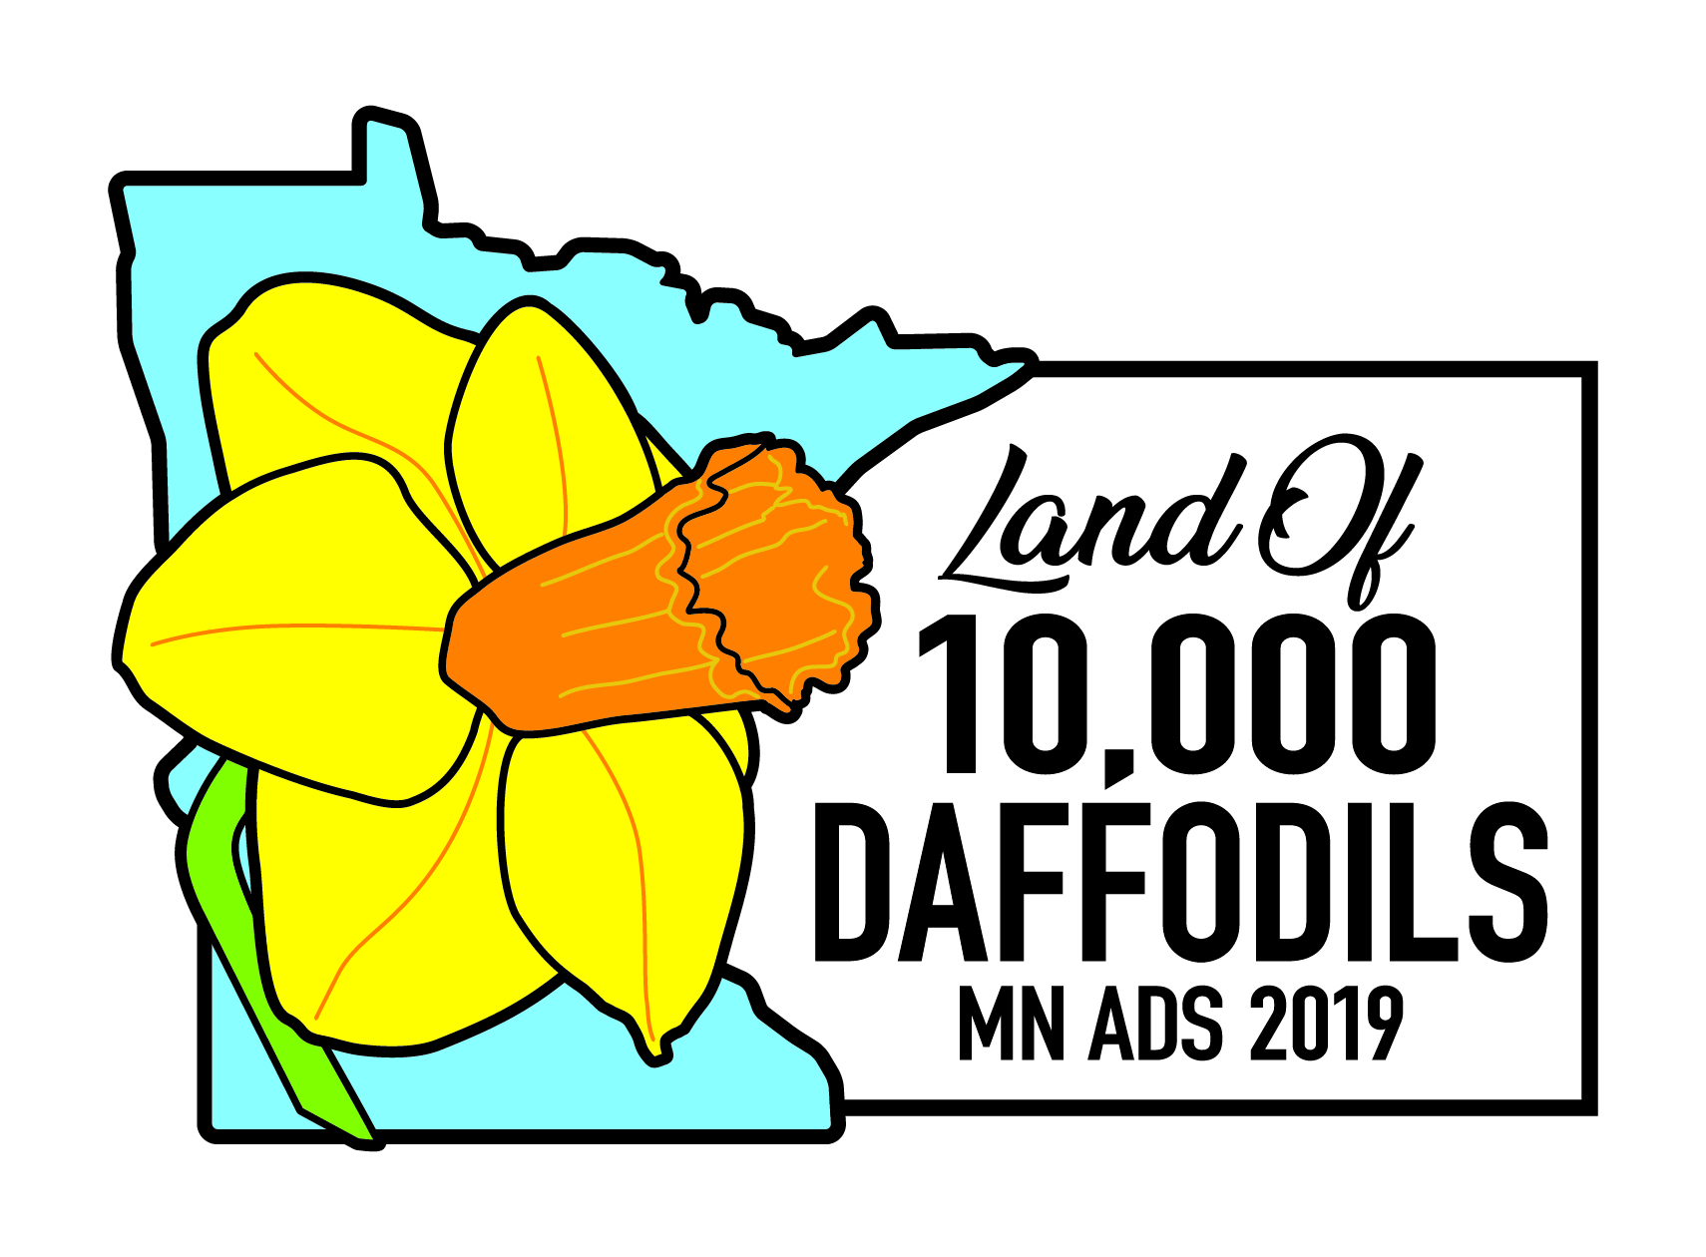
Hilton Minneapolis/Bloomington  3900 American Blvd. West  Bloomington, MN 55437 United States  Phone: (952) 893-9500 or (844) 856-8554  https://secure3.hilton.com/en_US/hi/reservation/book.htm?execution=e1s1  Hotel Code: “ADS” or “American Daffodil Society” |  | - Room Rate is $105.00 (king) or $110 (two queens) queens) plus taxes per night  - Rates guaranteed until April 5 or until block is sold out  - Free airport shuttle; free on-site parking  - Complimentary wireless internet
(Please complete a separate form for each attendee)

Name ___________________________________________________ Nickname for name tag _______________________________

Street Address _______________________________________________________________________________________________

City ________________________________________State ______________Zip ___________Country________________________

Telephone ______________________________E-mail (for confirmation) ________________________________________________

Special dietary needs: __________________________________________________________________________

The 2019 ADS Convention Registration Fee for the three-plus days includes:
- Friday evening dinner, Annual Membership Meeting, and Show Awards presentation
- Saturday entry to convention program sessions
- Saturday buffet lunch, bus to MN Landscape Arboretum, dinner with speaker Mike Heger of Ambergate Horticultural Consulting
- Sunday bus tour to two private daffodil gardens, with box lunch, and stop at Squire House Gardens in Afton, MN
- Sunday Judges Refresher, and dinner with speaker Ana Heck of the Univ. of Minnesota Bee Research Lab

Registration Fee:
Paid and Postmarked on or before April 1.….……...............................................................$350 ________
Paid and Postmarked after April 1 (tours subject to ability to add seats)..............................$380 _________
*Note: April 15 is the cut-off date for all registrations. Attendees are encouraged to pay on the ADS
Webstore, and mail or email the registration form per below. There will be no on-site registrations.

Optional Costs:
Optional Friday bus tour to three stellar Minneapolis parks, incl. box lunch ……………....$60__________
To receive ADS credit for Sunday morning Judges Refresher .………………..……………$ 5__________
2019 Convention logo’d cotton t-shirt – MUST be pre-ordered. Size: ________.................$15__________
Optional 1-hr TRAM ride at Saturday Arboretum–if not enough interest, will be refunded.. $ 5__________
Optional additional donation to the 2019 Daffodil Convention ..……………………………$ __________
TOTAL ENCLOSED.....................................$ _________

Check all that apply:  - This is my first ADS convention  - I would like to be a Mentor to a first timer  - I plan to bring cut flowers for the show  - I plan to bring potted daffodils for the show  - I plan to bring photos to enter in photo show | - I sent check(s) payable to “ADS” to:  Steve Horan  3674 Commonwealth Draw  Woodbury, MN 55125-4322  - I paid through the ADS Webstore.  https://stores.daffodilusastore.org/  *Send completed registration via US mail or email to Steve at address above or ads2019mn@gmail.com

EARLY DEADLINE: April 1, 2019. FINAL DEADLINE: April 15, 2019

